Transfer Discrepancies
Contents
Transfer Discrepancies 1
1 - Create Split PO with Commercial or Wholesale_IND = Y (POMA) [split PO to WH 1 and WH 3) 2
2 - Create ASN for the PO (ASOS NET) 2
2.1 - Receive full quantity for the shipment created on step 2 (via script 1) 2
Script1 2
3 - Create shipment for the Split PO's allocation (via script 2) 5
Script2: 5
3.1 - Receive less quantity than what was sent in the shipment ID 626745 (via script 3) 14
Script3: 14
4 - Execute the insert scripts for the tables int_receipt_close_head and int_receipt_close_detail 22
Script 4 22
Run below two Batches 23
Dashboard 23

Steps:

1 - Create Split PO with Commercial or Wholesale_IND = Y (POMA) [split PO to WH 1 and WH 3)

2 - Create ASN for the PO (ASOS NET)
At this moment, we should have 1 shipment [TO_LOC 1] on table shipment (generated by step 2)
Query: select * from rms.shipment where order_no ='500000609786'
SHIPMENT ID =626744
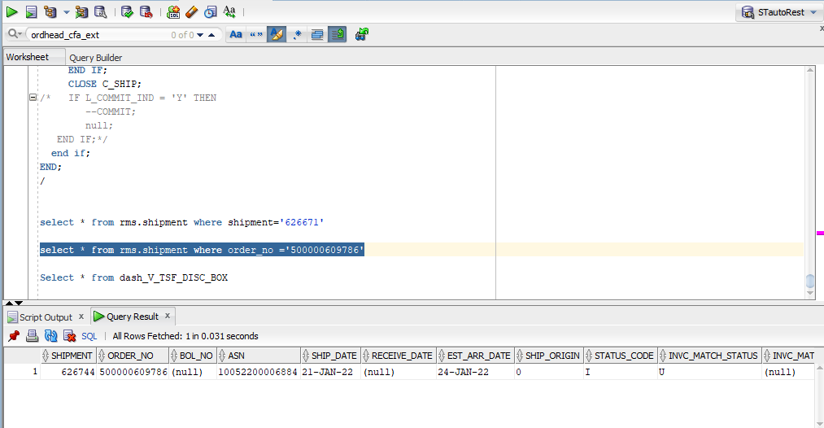

2.1 - Receive full quantity for the shipment created on step 2 (via script 1)

[SHIPMENT ID = 626744]

Script1
alter session set current_schema=RMS;

clear buffer;
set line 256;
set pagesize 1000;
set serveroutput on ;

declare
L_error_message RTK_ERRORS.RTK_TEXT%TYPE := NULL;
L_item_receiving_table RECEIVE_SQL.ITEM_RECV_TABLE;
I_shipment SHIPMENT.SHIPMENT%TYPE := 626744; --Shipment ID
--I_distro_content VARCHAR2 := NULL;
I_location SHIPMENT.TO_LOC%TYPE := 1;
I_asn_bol_no SHIPMENT.ASN%TYPE := '10052200006884'; -- ASN Number
I_order_no SHIPMENT.ORDER_NO%TYPE := 500000609786; -- PO Number
I_receipt_date SHIPMENT.RECEIVE_DATE%TYPE := sysdate;
I_disposition INV_STATUS_CODES.INV_STATUS_CODE%TYPE := 'ATS';

L_item ITEM_MASTER.ITEM%TYPE := '101026713'; -- SKU Number

begin
dbms_output.enable(50000);

if ORDER_RCV_SQL.PO_LINE_ITEM_ONLINE(L_error_message,
I_location,
I_order_no,
L_item,
20,--qty_received,
'R',
sysdate, --I_receipt_date,
I_order_no,
I_asn_bol_no,
NULL,
null, --carton,
NULL,
NULL,
NULL,
'ATS', --inv_status,
NULL,
'Y',
I_shipment,
null, --weight_received,
null--weight_received_uom
) = FALSE then
dbms_output.put_line('ERROR:' || L_error_message);
else
dbms_output.put_line('OK');

end if;

end;

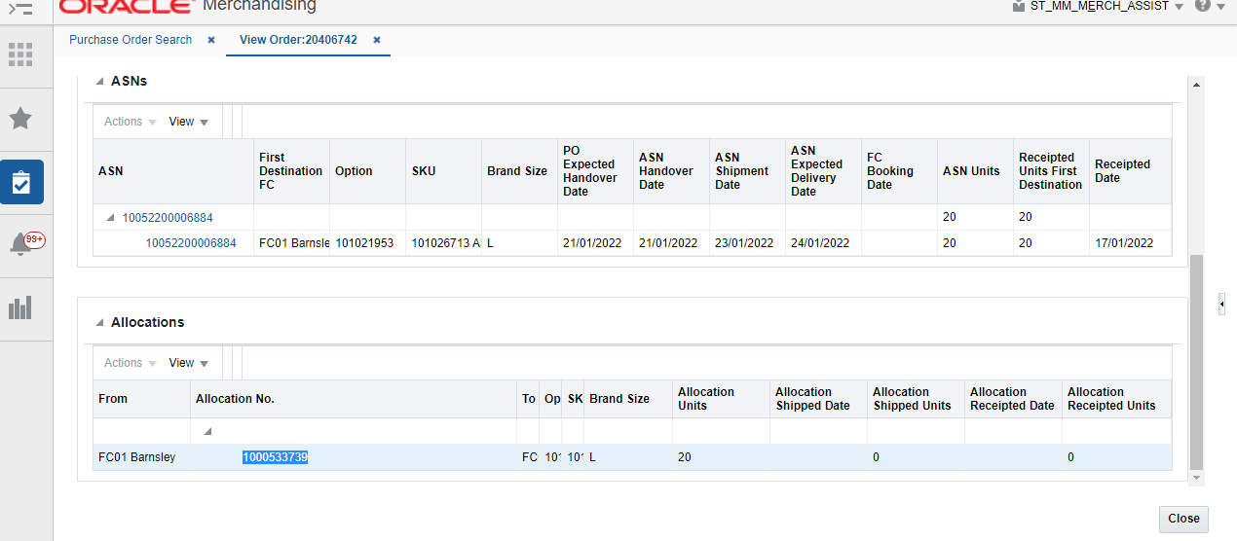

3 - Create shipment for the Split PO's allocation (via script 2)
Allocation no: 1000533739 from RMS UI

Note: Shipment id will be generated after script2 execution in PL/SQL (shipment : 626745)

Script2:

clear buffer;
--accept I_ALLOC_NO NUM PROMPT 'Enter Alloc Number: '
--accept I_commit_ind CHAR PROMPT 'Commit (Y/N): '
set serveroutput on size 1000000
set verify off

DECLARE
---------------------------------------------------------------
-- CONSTANT DECLARATIONS USED TO LIMIT RECORDS TO BE PROCESSED
L_ALLOC_NO ALLOC_HEADER.ALLOC_NO%TYPE := 1000533739;
---------------------------------------------------------------

------------------------------------------------------------------------------------------
-- 1
-- ERROR HANDLING and COMMON VARIABLES

O_ERROR_MESSAGE RTK_ERRORS.RTK_TEXT%TYPE;
O_STATUS_CODE VARCHAR2(20);
L_table VARCHAR2(255);
L_sqlcode NUMBER;
L_message_type VARCHAR2(15) := 'ASNOUTCRE';
L_package_name VARCHAR2(255) := 'RMSSUB_ASNOUT.CONSUME';
L_rib_oid NUMBER := 0;
------------------------------------------------------------------------------------------
------------------------------------------------------------------------------------------
-- 2
-- L_message = ASNOUTDesc Collection Initialisation

L_message "RIB_ASNOutDesc_REC" := NULL;

L_RIB_ASNOUTDISTRO_REC "RIB_ASNOutDistro_REC" := NULL;
L_RIB_ASNOUTDISTRO_TBL "RIB_ASNOutDistro_TBL" := NULL;

L_RIB_ASNOUTCTN_REC "RIB_ASNOutCtn_REC" := NULL;
L_RIB_ASNOUTCTN_TBL "RIB_ASNOutCtn_TBL" := NULL;

L_RIB_ASNOUTITEM_REC "RIB_ASNOutItem_REC" := NULL;
L_RIB_ASNOUTITEM_TBL "RIB_ASNOutItem_TBL" := NULL;
------------------------------------------------------------------------------------------
------------------------------------------------------------------------------------------
-- 3
-- Variables Required for processing message

L_FROM_LOC ALLOC_HEADER.WH%TYPE := NULL;
L_TO_LOC ALLOC_DETAIL.TO_LOC%TYPE := NULL;

I_BOL_NO SHIPMENT.BOL_NO%TYPE := L_ALLOC_NO||'11111';
I_CARTON SHIPSKU.CARTON%TYPE := L_ALLOC_NO||'123456789';

CURSOR C_ALLOC_HEADER (I_ALLOC_NO ALLOC_HEADER.ALLOC_NO%TYPE) IS
SELECT t.alloc_no,
t.wh,
d.to_loc,
d.to_loc_type
FROM ALLOC_HEADER T, ALLOC_DETAIL D WHERE T.ALLOC_NO=I_ALLOC_NO AND T.ALLOC_NO=D.ALLOC_NO;
R_ALLOC_HEADER C_ALLOC_HEADER%ROWTYPE;

CURSOR C_ALLOCDETAIL (I_ALLOC_NO ALLOC_DETAIL.ALLOC_NO%TYPE) IS
SELECT D.ALLOC_NO,H.ITEM,D.QTY_ALLOCATED SHIP_QTY
FROM ALLOC_DETAIL D , ALLOC_HEADER H
WHERE D.ALLOC_NO=I_ALLOC_NO
AND D.ALLOC_NO=H.ALLOC_NO
AND D.QTY_ALLOCATED > 0
ORDER BY H.ITEM;
R_ALLOC_DETAIL C_ALLOCDETAIL%ROWTYPE;

CURSOR C_WH (I_WH NUMBER) IS
SELECT WH.PHYSICAL_WH FROM WH WHERE WH = I_WH;

CURSOR C_SHIP (I_ALLOC_NO ALLOC_HEADER.ALLOC_NO%TYPE) IS
SELECT SHIPMENT
FROM SHIPSKU WHERE DISTRO_NO = I_ALLOC_NO
AND ROWNUM = 1;
R_SHIP C_SHIP%ROWTYPE;
------------------------------------------------------------------------------------------

BEGIN
dbms_output.enable(50000);

------------------------------------------------------------------------------------------
OPEN C_ALLOC_HEADER (L_ALLOC_NO);
FETCH C_ALLOC_HEADER INTO R_ALLOC_HEADER;
IF C_ALLOC_HEADER%NOTFOUND THEN
O_ERROR_MESSAGE := 'Alloc '||L_ALLOC_NO||' not found';
DBMS_OUTPUT.PUT_LINE(O_ERROR_MESSAGE);
CLOSE C_ALLOC_HEADER;
RETURN;
END IF;
CLOSE C_ALLOC_HEADER;

-- CHECK FOR PHYSICAL WAREHOUSE
--IF R_ALLOC_HEADER.FROM_LOC_TYPE = 'W' THEN
OPEN C_WH(R_ALLOC_HEADER.WH);
FETCH C_WH INTO L_FROM_LOC;
CLOSE C_WH;
--END IF;
--IF R_ALLOC_HEADER.TO_LOC_TYPE = 'W' THEN
-- OPEN C_WH(R_ALLOC_HEADER.TO_LOC);
-- FETCH C_WH INTO L_TO_LOC;
-- CLOSE C_WH;
--END IF;

--- ITEM
L_RIB_ASNOUTITEM_TBL := "RIB_ASNOutItem_TBL"();
OPEN C_ALLOCDETAIL(L_ALLOC_NO);
LOOP
FETCH C_ALLOCDETAIL INTO R_ALLOC_DETAIL;
EXIT WHEN C_ALLOCDETAIL%NOTFOUND;

L_RIB_ASNOUTITEM_REC := "RIB_ASNOutItem_REC"(L_rib_oid -- RIB_OID
,R_ALLOC_DETAIL.ITEM -- ITEM_ID
,R_ALLOC_DETAIL.SHIP_QTY -- UNIT_QTY
,NULL -- PRIORITY_LEVEL
,NULL -- ORDER_LINE_NBR
,NULL -- LOT_NBR
,NULL -- FINAL_LOCATION
,NULL -- FROM_DISPOSITION
,NULL -- TO_DISPOSITION
,NULL -- VOUCHER_NUMBER
,NULL -- VOUCHER_EXPIRATION_DATE
,NULL -- CONTAINER_QTY
);

L_RIB_ASNOUTITEM_TBL.EXTEND();
L_RIB_ASNOUTITEM_TBL(L_RIB_ASNOUTITEM_TBL.COUNT) := L_RIB_ASNOUTITEM_REC;

DBMS_OUTPUT.PUT_LINE('ITEM: '||R_ALLOC_DETAIL.ITEM||' QTY: '||R_ALLOC_DETAIL.SHIP_QTY);
END LOOP; -- TSFDETAIL
CLOSE C_ALLOCDETAIL;

--- CARTON
L_RIB_ASNOUTCTN_TBL := "RIB_ASNOutCtn_TBL"();
L_RIB_ASNOUTCTN_REC := "RIB_ASNOutCtn_REC"(L_rib_oid -- RIB_OID
,NULL -- FINAL_LOCATION
,I_CARTON -- CONTAINER_ID
,NULL -- CONTAINER_WEIGHT
,NULL -- CONTAINER_LENGTH
,NULL -- CONTAINER_WIDTH
,NULL -- CONTAINER_HEIGHT
,NULL -- CONTAINER_CUBE
,NULL -- EXPEDITE_FLAG
,NULL -- IN_STORE_DATE
,NULL -- TRACKING_NBR
,NULL -- FREIGHT_CHARGE
,NULL -- MASTER_CONTAINER_ID
,L_RIB_ASNOUTITEM_TBL
);

L_RIB_ASNOUTCTN_TBL.EXTEND();
L_RIB_ASNOUTCTN_TBL(L_RIB_ASNOUTCTN_TBL.COUNT) := L_RIB_ASNOUTCTN_REC;

---DISTRO
L_RIB_ASNOUTDISTRO_TBL := "RIB_ASNOutDistro_TBL"();
L_RIB_ASNOUTDISTRO_REC := "RIB_ASNOutDistro_REC"(L_rib_oid -- RIB_OID
,R_ALLOC_HEADER.ALLOC_NO -- DISTRO_NBR
,'A' -- (ALLOCATION) DISTRO_DOC_TYPE
,NULL -- CUSTOMER_ORDER_NBR
,NULL -- FULFILL_ORDER_NBR
,NULL -- CONSUMER_DIRECT
,L_RIB_ASNOUTCTN_TBL
);

L_RIB_ASNOUTDISTRO_TBL.EXTEND();
L_RIB_ASNOUTDISTRO_TBL(L_RIB_ASNOUTDISTRO_TBL.COUNT) := L_RIB_ASNOUTDISTRO_REC;

L_message := "RIB_ASNOutDesc_REC"(L_rib_oid -- RIB_OID
,NULL -- SCHEDULE_NBR
,NULL -- AUTO_RECEIVE
,3 -- TO_LOCATION
,R_ALLOC_HEADER.TO_LOC_TYPE -- TO_LOC_TYPE
,NULL -- TO_STORE_TYPE
,'Y' -- TO_STOCKHOLDING_IND
,1 -- FROM_LOCATION
,'W'--R_ALLOC_HEADER.FROM_LOC_TYPE -- FROM_LOC_TYPE
,NULL -- FROM_STORE_TYPE
,'Y' -- FROM_STOCKHOLDING_IND
,I_BOL_NO -- ASN_NBR --> SHIPMENT.BOL_NO
,NULL -- ASN_TYPE
,NULL -- CONTAINER_QTY
,NULL -- BOL_NBR --> SHIPMENT.EXT_REF_NO_OUT
,GET_VDATE -- SHIPMENT_DATE
,GET_VDATE + 1 -- EST_ARR_DATE
,NULL -- SHIP_ADDRESS1
,NULL -- SHIP_ADDRESS2
,NULL -- SHIP_ADDRESS3
,NULL -- SHIP_ADDRESS4
,NULL -- SHIP_ADDRESS5
,NULL -- SHIP_CITY
,NULL -- SHIP_STATE
,NULL -- SHIP_ZIP
,NULL -- SHIP_COUNTRY_ID
,NULL -- TRAILER_NBR
,NULL -- SEAL_NBR
,NULL -- TRANSSHIPMENT_NBR
,L_RIB_ASNOUTDISTRO_TBL
);

------------------------------------------------------------------------------------------
RMSSUB_ASNOUT.CONSUME(O_STATUS_CODE,
O_ERROR_MESSAGE,
L_message,
L_message_type);

if O_STATUS_CODE not in ('S') then
DBMS_OUTPUT.PUT_LINE('Status Code:'||O_STATUS_CODE||':');
SQL_LIB.BATCH_MSG(L_sqlcode,L_table,O_ERROR_MESSAGE);
DBMS_OUTPUT.PUT_LINE('Error msg:'||O_ERROR_MESSAGE||':');
else
DBMS_OUTPUT.PUT_LINE(L_package_name||' Executed successfully!!');

-- SENDS THE SHIPMENT NUMBER CREATED
OPEN C_SHIP (L_ALLOC_NO);
FETCH C_SHIP INTO R_SHIP;
IF C_SHIP%NOTFOUND THEN
O_ERROR_MESSAGE := 'shipment for transfer '||L_ALLOC_NO||' not found';
DBMS_OUTPUT.PUT_LINE(O_ERROR_MESSAGE);
CLOSE C_SHIP;
RETURN;
ELSE
DBMS_OUTPUT.PUT_LINE('shipment : '||r_ship.shipment||' was created successfully');
END IF;
CLOSE C_SHIP;
/* IF L_COMMIT_IND = 'Y' THEN
--COMMIT;
null;
END IF;*/
end if;
END;

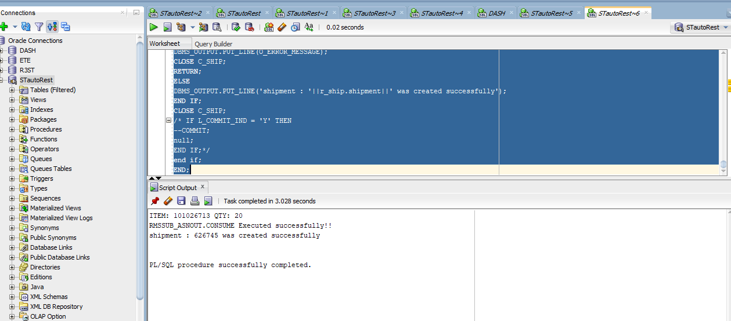

At this moment, we should have 1 shipment [TO_LOC 3] on table shipment (generated by step 3) [SHIPMENT ID = 626745]

3.1 - Receive less quantity than what was sent in the shipment ID 626745 (via script 3)

At this moment, we should have shipment.receive_qty = total_qty-2 [SHIPMENT ID = 626745]

Script3:
clear buffer;
set serveroutput on
set verify off

DECLARE
---------------------------------------------------------------
-- CONSTANT DECLARATIONS USED TO LIMIT RECORDS TO BE PROCESSED
L_SHIPMENT SHIPMENT.SHIPMENT%TYPE := 626745;
---------------------------------------------------------------

------------------------------------------------------------------------------------------
-- 1
-- ERROR HANDLING and COMMON VARIABLES

O_ERROR_MESSAGE RTK_ERRORS.RTK_TEXT%TYPE;
O_STATUS_CODE VARCHAR2(20);
L_table VARCHAR2(255);
L_sqlcode NUMBER;
L_message_type VARCHAR2(15) := 'RECEIPTCRE';
L_package_name VARCHAR2(255) := 'RMSSUB_RECEIPT.CONSUME';
L_rib_oid NUMBER := 0;
------------------------------------------------------------------------------------------
------------------------------------------------------------------------------------------
-- 2
-- L_message = RECEIPT Collection Initialisation

L_message "RIB_ReceiptDesc_REC" := NULL;
O_RIB_ERROR_TBL "RIB_ERROR_TBL" := NULL;
L_RIB_OTBDESC "RIB_OTBDesc_REC" := NULL;

L_RIB_RECEIPT_REC "RIB_Receipt_REC" := NULL;
L_RIB_RECEIPT_TBL "RIB_Receipt_TBL" := NULL;

L_RIB_RECEIPTDTL_REC "RIB_ReceiptDtl_REC" := NULL;
L_RIB_RECEIPTDTL_TBL "RIB_ReceiptDtl_TBL" := NULL;

------------------------------------------------------------------------------------------
------------------------------------------------------------------------------------------
-- 3
-- Variables Required for processing message

CURSOR C_SHIP (I_SHIPMENT SHIPMENT.SHIPMENT%TYPE) IS
SELECT * FROM SHIPMENT WHERE SHIPMENT = I_SHIPMENT;
R_SHIP C_SHIP%ROWTYPE;

CURSOR C_TSF (I_TSF_NO TSFHEAD.TSF_NO%TYPE) IS
SELECT * FROM TSFHEAD T WHERE T.TSF_NO = I_TSF_NO;
R_TSF C_TSF%ROWTYPE;

CURSOR C_ALLOC (I_ALLOC_NO ALLOC_HEADER.ALLOC_NO%TYPE) IS
SELECT * FROM ALLOC_HEADER A WHERE A.ALLOC_NO = I_ALLOC_NO;
R_ALLOC C_ALLOC%ROWTYPE;

L_EXIST BOOLEAN;
L_DISTRO_TYPE VARCHAR2(1);
L_TSF_ALLO_NO TSFHEAD.TSF_NO%TYPE := NULL;

------------------------------------------------------------------------------------------

BEGIN
dbms_output.enable(50000);

------------------------------------------------------------------------------------------
-- GET SHIPMENT DATA
OPEN C_SHIP (L_SHIPMENT);
FETCH C_SHIP INTO R_SHIP;
IF C_SHIP%NOTFOUND THEN
CLOSE C_SHIP;
O_ERROR_MESSAGE := 'shipment '||l_shipment||' doesn''t exist in database';
DBMS_OUTPUT.PUT_LINE(O_ERROR_MESSAGE);
RETURN;
END IF;
CLOSE C_SHIP;

IF R_SHIP.ORDER_NO IS NULL THEN

-- THE DOCUMENTS (TRANSFERS AND/ OR ALLOCATIONS) ARE AT THE SHIPSKU LEVEL

FOR R_DISTRO IN (SELECT DISTINCT SK.SHIPMENT, SK.DISTRO_NO
FROM SHIPSKU SK
WHERE SK.SHIPMENT = R_SHIP.SHIPMENT
ORDER BY 1
)
LOOP
OPEN C_TSF (R_DISTRO.DISTRO_NO);
FETCH C_TSF INTO R_TSF;
L_EXIST := C_TSF%FOUND;
CLOSE C_TSF;
IF L_EXIST THEN
L_DISTRO_TYPE := 'T'; --TRANSFER
ELSE
OPEN C_ALLOC (R_DISTRO.DISTRO_NO);
FETCH C_ALLOC INTO R_ALLOC;
L_EXIST := C_ALLOC%FOUND;
CLOSE C_ALLOC;
IF L_EXIST THEN
L_DISTRO_TYPE := 'A'; --ALLOCATION
ELSE
O_ERROR_MESSAGE := 'distro '||r_distro.distro_no||' doesn''t exist in database';
DBMS_OUTPUT.PUT_LINE(O_ERROR_MESSAGE);
RETURN;
END IF;
END IF;

L_TSF_ALLO_NO := R_DISTRO.DISTRO_NO;

FOR R_ITEM IN (SELECT SK.ITEM,SK.CARTON,SK.QTY_EXPECTED -2 AS QTY_EXPECTED
FROM SHIPSKU SK
WHERE SK.SHIPMENT = R_DISTRO.SHIPMENT
AND SK.DISTRO_NO = R_DISTRO.DISTRO_NO
ORDER BY 1
)
LOOP
L_RIB_RECEIPTDTL_TBL := "RIB_ReceiptDtl_TBL"();
L_RIB_RECEIPTDTL_REC := "RIB_ReceiptDtl_REC"(L_rib_oid
,R_ITEM.ITEM -- ITEM_ID
,R_ITEM.QTY_EXPECTED -- UNIT_QTY
,'R' -- RECEIPT_XACTN_TYPE
,GET_VDATE -- RECEIPT_DATE
,NULL -- RECEIPT_NBR
,NULL -- DEST_ID
,R_ITEM.CARTON -- CONTAINER_ID
,NULL --ref_container_id
,NULL -- DISTRO_NBR
,NULL -- DISTRO_DOC_TYPE
,'ATS' -- TO_DISPOSITION
,'ATS' -- FROM_DISPOSITION
,NULL -- TO_WIP
,NULL -- FROM_WIP
,NULL -- TO_TROUBLE
,NULL -- FROM_TROUBLE
,NULL -- USER_ID
);

L_RIB_RECEIPTDTL_TBL.EXTEND();
L_RIB_RECEIPTDTL_TBL(L_RIB_RECEIPTDTL_TBL.COUNT) := L_RIB_RECEIPTDTL_REC;

END LOOP;

L_RIB_RECEIPT_TBL := "RIB_Receipt_TBL"();
L_RIB_RECEIPT_REC := "RIB_Receipt_REC"(L_rib_oid
,R_SHIP.TO_LOC -- DC_DEST_ID >> PHYSICAL WH OR STORE NUMBER
,R_DISTRO.DISTRO_NO -- TRANSFER/ALLOC NUMBER
,NULL -- CUST_ORDER_NBR
,NULL -- FULFILL_ORDER_NBR
,L_DISTRO_TYPE -- DOCUMENT_TYPE
,R_SHIP.REF_DOC_NO -- REF_DOC_NO
,R_SHIP.BOL_NO -- ASN_NBR
,L_RIB_RECEIPTDTL_TBL
);
L_RIB_RECEIPT_TBL.EXTEND();
L_RIB_RECEIPT_TBL(L_RIB_RECEIPT_TBL.COUNT) := L_RIB_RECEIPT_REC;
END LOOP;

L_message := "RIB_ReceiptDesc_REC"(L_rib_oid -- RIB_OID NUMBER
,NULL -- SCHEDULE_NBR
,NULL -- APPT_NBR
,L_RIB_RECEIPT_TBL
);
END IF;

------------------------------------------------------------------------------------------
IF RMSSUB_RECEIPT.CONSUME(O_STATUS_CODE
,O_ERROR_MESSAGE
,L_message
,L_message_type
,L_RIB_OTBDESC
,O_RIB_ERROR_TBL ) = FALSE THEN

DBMS_OUTPUT.PUT_LINE('Status Code:'||O_STATUS_CODE||':');
SQL_LIB.BATCH_MSG(L_sqlcode,L_table,O_ERROR_MESSAGE);
DBMS_OUTPUT.PUT_LINE('Error msg:'||O_ERROR_MESSAGE||':');
ELSE
DBMS_OUTPUT.PUT_LINE(L_package_name||' Executed successfully!!');
DBMS_OUTPUT.PUT_LINE('Shipment '||l_shipment||' for distro_no: '|| l_tsf_allo_no||' of type: ('||l_distro_type||') successfully received');
END IF;

END;

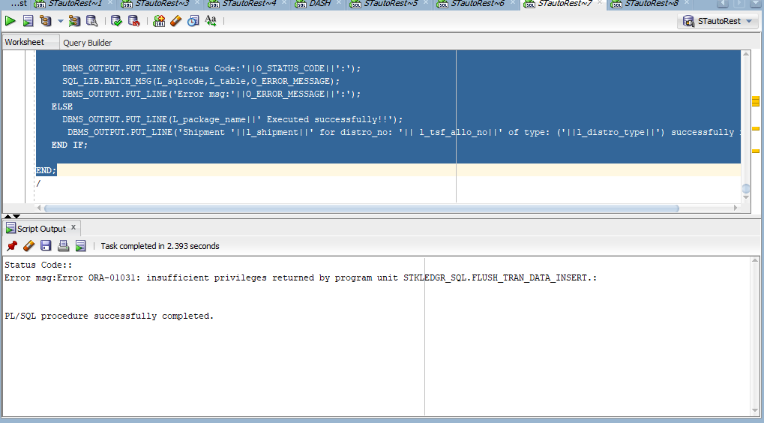

4 - Execute the insert scripts for the tables int_receipt_close_head and int_receipt_close_detail
Make sure that shipment.comments is not null (in ETE this should be all done automatically)
(via script 4)

Script 4

update rms.shipment set comments = 'a' where shipment = 626745;

insert into int_asos.int_receipt_close_head
values (626745, null, null, 1005220000688411111, 3, '17-JAN-22', 'Ashutosh', '12-JAN-22', 'Ashutosh', '17-JAN-22');

insert into int_asos.int_receipt_close_detail
values (626745, 101026713, 20, 1005220000688412345, 'Y', 'Ashutosh', '17-JAN-22', 'Ashutosh', '17-JAN-22');

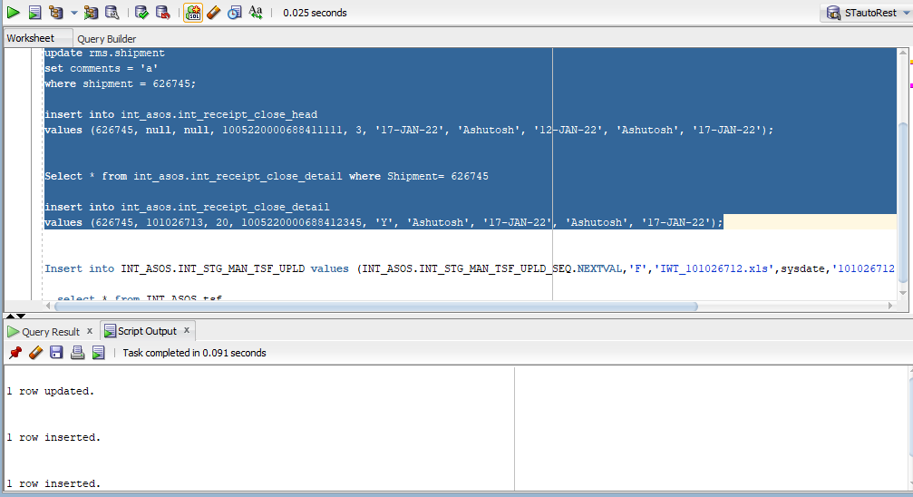

Run below two Batches

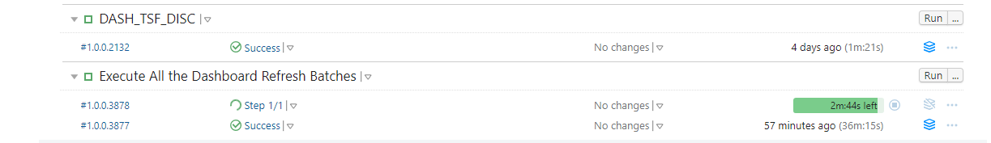

Dashboard
